**Ebola Sierra Leone Metadata Release**

The Excel spreadsheets included alongside this document correspond to the data used in the analysis presented in the paper published in the New England Journal of Medicine, entitled “Clinical Illness and Outcomes in Patients with Ebola in Sierra Leone”, by John S. Schieffelin, et al.

<http://www.nejm.org/doi/full/10.1056/NEJMoa1411680>

This data comprises a total of 213 cases evaluated for Ebola virus infection at the Kenema Government Hospital in Sierra Leone between May 25 and June 18, 2014. Outcome data was available for 87 of 106 EBOV positive cases. Metabolic panels were performed on 98 Ebola virus disease and non-Ebola virus disease illness patients with adequate samples volumes. Ebola virus load was determined in 63 cases with adequate samples volumes by quantitative polymerase chain reaction (qPCR) at Harvard University. Sign and symptom data was obtained on 44 patients with a clinical chart that were admitted to Kenema Hospital. The following figure summarizes these counts:

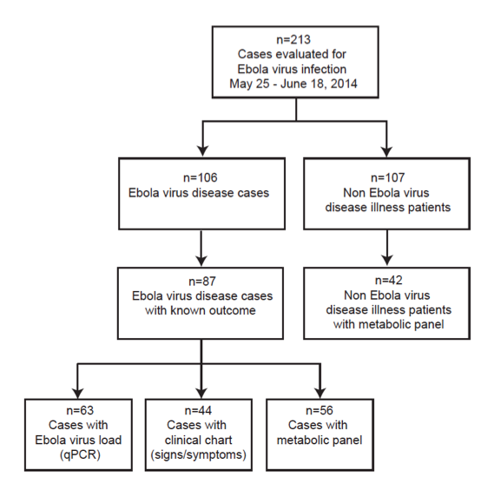

The metabolic panels were obtained from serum samples analyzed with a Piccolo Blood Chemistry Analyzer and Comprehensive Metabolic Reagent Discs (Abaxis). Manufacturer specifications are available at:

<http://www.abaxis.com/pdf/Comprehensive%20Metabolic%20Panel.pdf>

Piccolo measurements at different time points along treatment are available for some of the Ebola-positive patients.

**Summary description of Excel spreadsheets**

**1)** MasterDataListandEBOVResults.xlsx

Master list of patients, with PCR results for each (some have PCR results available at different time points)

**2)** DemographicsFromSim_schieffelin.xlsx

This table contains basic demographic and outcome data.

**3)** CaseNotification_schieffelin.xlsx

Table holding clinical symptoms and medication for a subgroup of patients.

**4)** FinalPiccoloData_schieffelin.xlsx

This table contains the Piccolo metabolic panel. Values are provided in Common and SI units, when they differ.

**Contact Information**

John Schieffelin: [jschieff@tulane.edu](mailto:jschieff@tulane.edu)

Robert Gary: [rfgarry@tulane.edu](mailto:rfgarry@tulane.edu)

Andres Colubri: [andres@broadinstitute.org](mailto:andres@broadinstitute.org)

Pardis Sabeti: [pardis@broadinstitute.org](mailto:pardis@broadinstitute.org)